3D model Stuff/Math/Ratio/Measurements

### **Instruction:**

*Once this is complete, today's activity is a team assignment for all class participants. In your teams, you should design an RC-like car that you will build next week in class. It will not really be RC as you will get an electric motor that you will power with two AA batteries for your vehicle to make a straight line run.

You will submit your work via the Google form below. The work can be shared, but every teammate needs to submit the form. For this exercise you should be focusing on building your vehicle correctly to the scale factors you calculate, accuracy and neatness of the design, and sharing the tools and workspace collegially. The steps are as follows:

1) Find a real 4 wheel vehicle that you are replicating. Please consider its appropriateness to build with bamboo sticks, cardboard, hobby wheels, an RC engine and hot glue. Images of your supplies below) Download its image or schematic and submit in the Google Form (you can do this submission at the end). Your car will not need to steer. We will be trying to achieve straight line runs.

2) The hobby tires you are using for this assignment will be 30mm in diameter. Calculate what the scaling factor needs to be for your vehicle to be crafted with 30mm hobby tires. For example, if the vehicle your team has chosen to build has tires 1 meter in diameter, you will be building 30/1000 = 3/100 scale. (If you cannot figure out tire dimension of your vehicle after Googling it, it is OK to be intelligently approximate. Or you may need to pick an alternative vehicle that allows you to make this calculation) Your scaling will be asked in the form.

3) Draw on paper (we should have graph paper avail for you) or design in TinkerCAD a vehicle that is to scale with your design. For example if you vehicle is 5 meters long and 2 meters wide, and you are designing to scale, your vehicle should be 5000*3/100 = 150mm (approx 6 inches). Submit a photo or screenshot of your design in the Google Form.

**[Here is the Assignment Form You will Fill Out for Credit.](https://docs.google.com/forms/d/e/1FAIpQLSdR_qFxjugUdCABmNJ8KYS6DEDm6ipv6XXFavICmwRacX2k2g/viewform?usp=sf_link)**

[(Links to an external site.)](https://docs.google.com/forms/d/e/1FAIpQLSdR_qFxjugUdCABmNJ8KYS6DEDm6ipv6XXFavICmwRacX2k2g/viewform?usp=sf_link)

Below are images and scale of some of the supplies you will be provided:

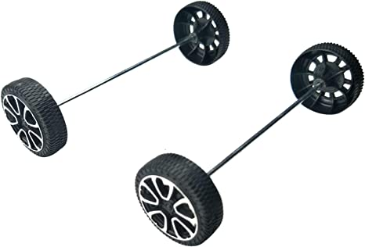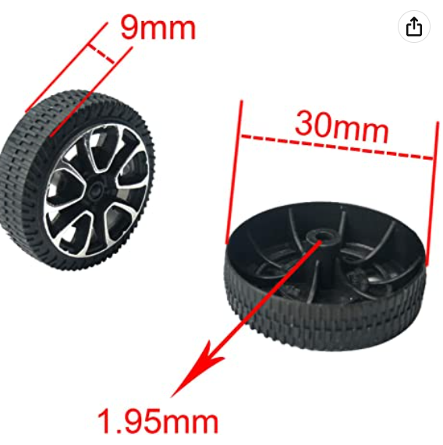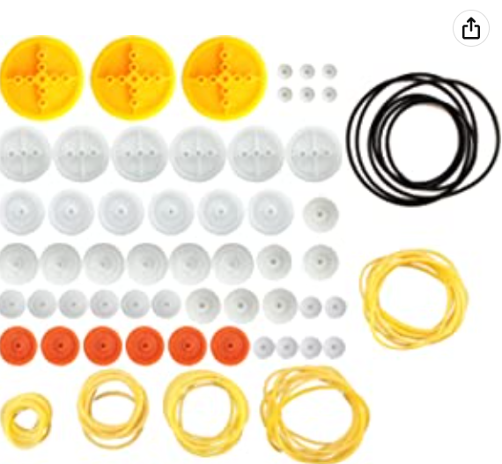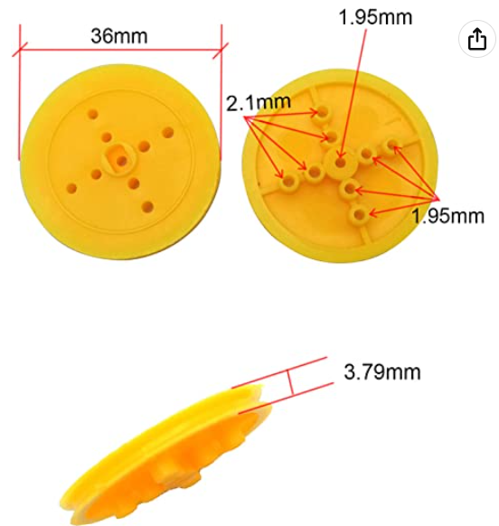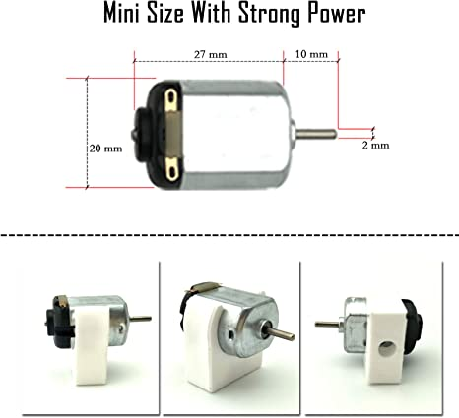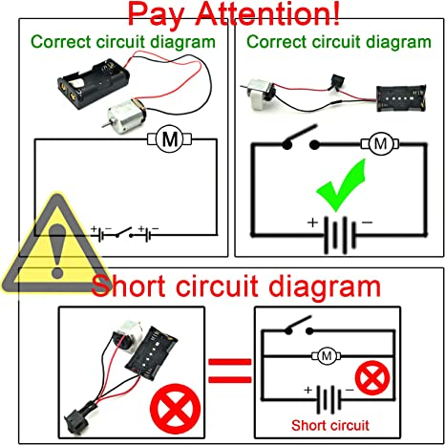

Below is a rough example of a design that is OK but may not get full credit because the scaling proportions of the body features get messed up between the image inspiring the design and the actual build. For example the doors of the balsa and cardboard vehicle are too short relative to the body and too tall cab. It shows good effort though and attention to neatness and detail.*

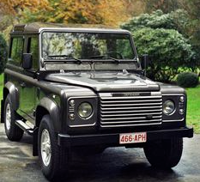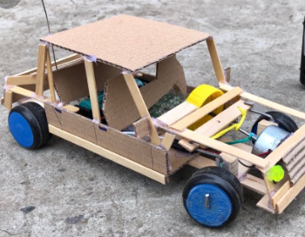

### **Inspo:**

<https://www.instructables.com/3D-Printed-RC-Car-Open-Source/>

<https://www.mbusa.com/en/vehicles/class/amg-gt/coupe>

Mercedes AMG GT coupe (4 door)

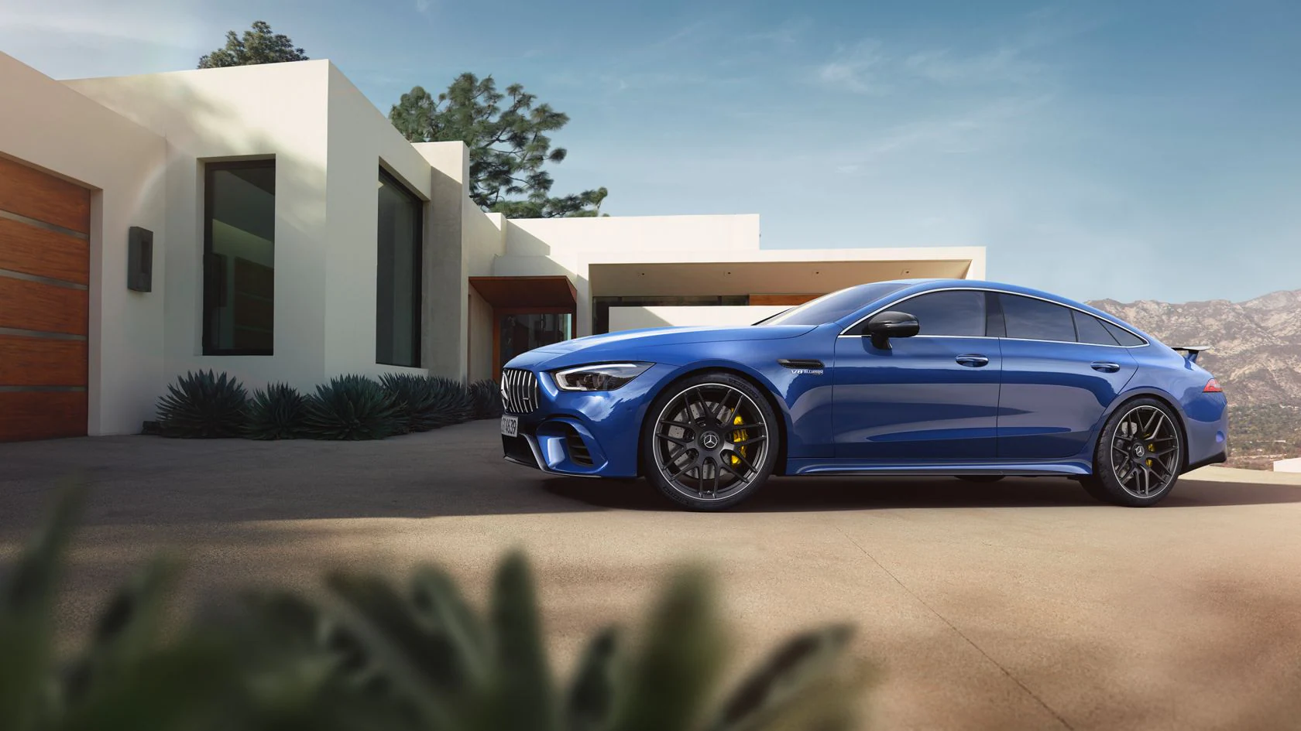

**Mercedes-AMG GT 4-Door Coupé (X290)**

Wheelbase 2,951 mm (116.2 in)

Length 5,054 mm (199.0 in

Width 1,953 mm (76.9 in)

Height 1,442–1,455 mm (56.8–57.3 in)

**Tire**

Diameter 711

Width 255

Sidewall 114

Circum. 2235

Revs/km 447

**Ratio:** 30/711

**Scale lengths:**

Length: 210mm = 8.3

Width 82.4mm = 3.3

Height: 61.4mm = 2.4

Wheelbase: 124.5mm 4.9

